

**Media Contact:**Sarah Wynn Benton/Jennifer Walker  
BRAVE Public Relations  
404.233.3993  
[sbenton@emailbrave.com](mailto:sbenton@emailbrave.com)/  
[jwalker@emailbrave.com](mailto:jwalker@emailbrave.com)

FOR IMMEDIATE RELEASE

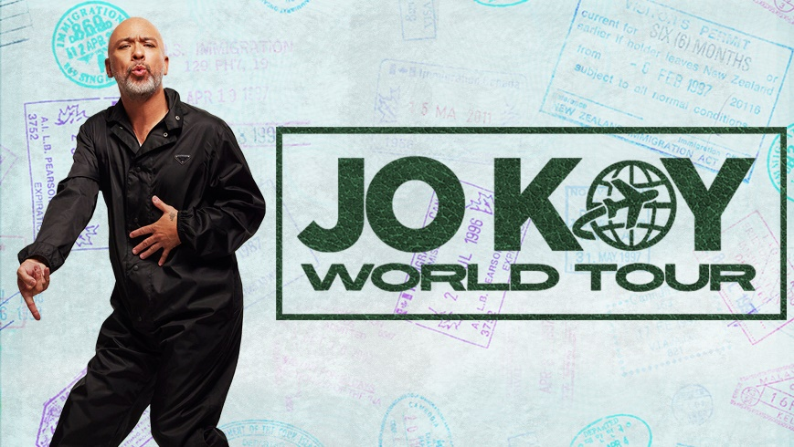

**Comedian Jo Koy Announces His 2023 Jo Koy World Tour***Tickets Go On-Sale Sept. 16 at 10 a.m.*

ATLANTA, GA – (Sept. 14, 2022) – Coming off of the highly anticipated Universal Picture film, “Easter Sunday” and his newly released Netflix special, *Jo Koy: Live From The Los Angeles Forum*, Comedian Jo Koy announces his 2023 *Jo Koy World Tour.* Venue pre-sale will begin on Thursday, Sept. 15 at 10 a.m. and tickets go on-sale Friday, Sept. 16 at 10 a.m. Tickets will be available to purchase at [foxtheatre.org](https://www.foxtheatre.org/) or by calling **855-285-8499**.

Marquee Club access is now available with Marquee Club Level seats only. Club Level seats are in the front balcony (the Loge) section of the theatre and available for purchase at the on-sale. For information on a variety of annual membership packages with Club Level seats, please email [sales@foxtheatre.org.](mailto:sales@foxtheatre.org?subject=Marquee%20Club%20Membership%20Inquiry%20)

Koy started 2022 with a bang, selling-out the Climate Pledge Arena (over 14,000 tickets) in his hometown of Seattle. Today, he continues breaking sales records at some of the most prestigious venues around the world including Mall of Asia Arena (Manila, PH), The Forum (Los Angeles), Coca-Cola Arena (Dubai), ICC Theatre (Sydney, AU) and Radio City Music Hall (New York City) to name a few. In November 2022, Koy will headline for the first time at Madison Square Garden for the NYCF. In 2017, Koy broke a record for the most tickets sold by a single artist at 23,000 tickets and 11 sold-out shows at The Neal S. Blaisdell Concert Hall in Honolulu. In response, the mayor’s office in Honolulu proclaimed Nov. 24 as “Jo Koy Day.” The *Jo Koy World Tour* will feature ALL NEW material.

As one of today’s premiere stand-up comedians, Jo Koy has come a long way from his modest beginnings performing in a Las Vegas coffee house. Jo’s uniquely relatable comedy pulls inspiration from his colorful family that has reached all kinds of people and has translated into sold-out arenas around the world.

His highly anticipated fourth Netflix stand-up special, “Live From The Los Angeles Forum” will premiere globally on Sept. 13. The special is a follow up to his 2019 Netflix special, Comin’ In Hot. Koy has already had four highly rated and successful stand-up specials on Comedy Central and Netflix. In June 2020, the comedian released his first variety special, “Jo Koy: In His Elements” on Netflix in which Koy brings the laughs and beats to Manila, spotlighting local culture in a one-of-a-kind show featuring Filipino-American comedians, DJs and B-boys.

For up-to-date information regarding the Fox Theatre’s health and safety protocols, please visit [foxtheatre.org/events/covid-19-updates](https://www.foxtheatre.org/events/covid-19-updates). All ticket holders will be notified of health and safety requirements prior to the event date.

**###**

**About the Fox Theatre**

The Fox Theatre is one of Atlanta's premier venues for live entertainment, welcoming more than 250 performances a year in its 4,665-seat theatre. From rock concerts and Broadway productions to ballets, comedy, and movies, the historic venue attracts more than 500,000 visitors annually. The theatre also hosts over 100 annual private events like wedding receptions, trade shows, corporate meetings, and association functions in its fabulous ballrooms, outdoor terrace, and [Marquee Club](https://www.foxtheatre.org/lexus-marquee-club) presented by Lexus. As a 501(c)(3) nonprofit arts organization, the Fox Theatre stands today as a fiercely protected landmark and a nationally acclaimed theater. The Fox Theatre proudly acknowledges its partners for their generous support: Coca-Cola, Lexus, Georgian Terrace Hotel, Georgia Natural Gas, Atlanta Beverage-Yuengling, Regions, and Grady Health System. Tickets for all events are available at the Fox Theatre Ticket Office, online at [FoxTheatre.org](https://protect-us.mimecast.com/s/v0QXCOYoRKcNvKACmEBXS?domain=secure-web.cisco.com), or toll-free at 855-285-8499. Group sales information is available by calling 404- 881-2000 or visiting the [foxtheatre.org/groups.](https://www.foxtheatre.org/events/group-sales) Stay connected by following @theFoxTheatre on [Instagram](https://protect-us.mimecast.com/s/SE2wCPNp8Li03x4HxEXzY?domain=secure-web.cisco.com), [Twitter](https://protect-us.mimecast.com/s/6oQPCQWqRMHXoW6i7XoPc?domain=secure-web.cisco.com), [and Facebook](https://protect-us.mimecast.com/s/kDgUCR6r7NtG5LrIZrWlF?domain=secure-web.cisco.com).

**Notable accolades** include 2019 Venues Now #1 Top Stop of the Decade Award for tickets sold (5,000 seats or less); 2019 Billboard #2 Highest Grossing Venue Worldwide (5,000 seats or less); 2019 Pollstar #3 Worldwide Ticket Sales (5,000 seats or less)